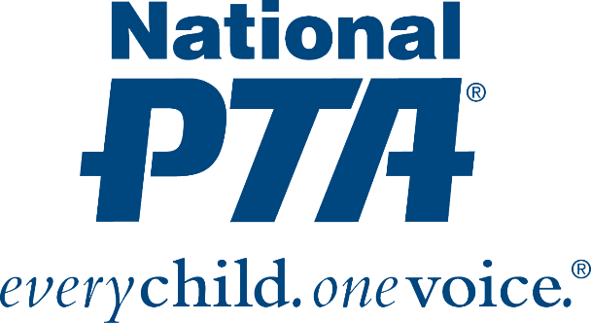

**Sample Social Media Messaging**

For Facebook, Twitter or Instagram

.@NationalPTA teamed up w/ @Act4HlthyKids on a NEW grant opportunity for PTAs funded by @ALDIUSA <http://bit.ly/1aZzelj> [Insert Graphic]

Need new gym supplies? @NationalPTA's grant w/ @Act4HlthyKids funded by @AldiUSA can help! <http://bit.ly/1aZzelj> [Insert Graphic]

PTA Members 📢 You can apply for this NEW grant to make every kid healthy & ready to learn! <http://bit.ly/1aZzelj> [Insert Graphic]

A new Parents for Healthy Grant in collaboration w/ @Act4HlthyKids is open! Help students be physically active!! Apply now: <http://bit.ly/1aZzelj> [Insert Graphic]

Apply by April 17 to be eligible for @Act4HlthyKids and @NationalPTA new grant to help your kids be physically active at school! 💪 <http://bit.ly/1aZzelj> [Insert Graphic]





**Sample E-Mail Messaging to PTA Members**

Subject: School Health Grants Available for your PTA

National PTA, Action for Healthy Kids (AFHK) and Aldi have joined forces to award Parents for Healthy Kids Grants, ranging from $500 to $1K, to support physical activity and nutrition initiatives in 150 schools in select states (including ours!). These grants provide funding for parent groups (priority will be given to local PTA units) to lead school-based physical activity and nutrition initiatives. Interested schools should submit a proposal that includes a physical activity AND nutrition component that are led by a parent(s).

[Learn more](http://www.actionforhealthykids.org/tools-for-schools/apply-for-grants) and apply today! Deadline: April 7, 2017.