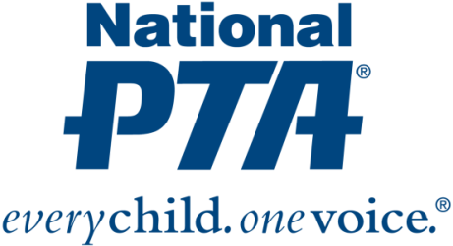
Media Contact
Heidi May Wilson, National PTA
hmay@pta.org, (703) 518-1242

National PTA Statement on President Obama’s 2017 Budget Proposal

ALEXANDRIA, Va., (Feb. 10, 2016) — Yesterday, President Barack Obama presented to Congress his proposal for the Fiscal Year 2017 budget.

“President Obama’s proposed increase of 2% over the Fiscal Year 2016 appropriation for education is positive, and there are key investments in programs that support students and schools,” said Laura Bay, president of National PTA. “However, National PTA is disappointed that funding for the Statewide Family Engagement Centers program was not included in the president’s proposal.”

The Statewide Family Engagement Centers program is included in the Every Student Succeeds Act—the new law governing the federal role in K-12 education. The program would provide states and districts with the capacity to support effective implementation and enhancement of family engagement policies and initiatives that are proven to make a difference for children, schools and communities.

“For years, PTA members and families nationwide have been advocating for the prioritization of family engagement as it is critical to student success and school improvement efforts,” added Nathan R. Monell, CAE, National PTA executive director. “National PTA remains committed to working to ensure the administration and Congress adequately invest in the Statewide Family Engagement Centers program to give families the tools to support their children’s achievement and give districts the resources to build meaningful family-school partnerships.”

In addition to the Statewide Family Engagement Centers program, National PTA also is disappointed that considerable increases for special education were not proposed. Greater financial support is essential for schools to be able to provide a quality education to children with disabilities.

National PTA is pleased, however, to see President Obama emphasize the importance of early learning and designate more resources for disadvantaged students. The association commends President Obama for proposing an increase of $450 million for Title I—which provides assistance to schools with high percentages of children from low-income families—and an increase of $100 million for Preschool Development Grants, which fund state efforts to expand and strengthen pre-K programs.

“One of the best investments our nation can make in a child’s life is in high-quality early education,” said Bay. “National PTA applauds President Obama’s continued commitment to improve access to early learning programs for all children to better prepare them for long-term success.”

About National PTA
National PTA® comprises millions of families, students, teachers, administrators, and business and community leaders devoted to the educational success of children and the promotion of parent involvement in schools. PTA is a registered 501(c)(3) nonprofit association that prides itself on being a powerful voice for all children, a relevant resource for families and communities, and a strong advocate for public education. Membership in PTA is open to anyone who wants to be involved and make a difference for the education, health, and welfare of children and youth.

